**Assignment 1**

**15 git command.**

**1).git –version -**

* This will show the version of git installed.



**2). git init -**

* The git init command creates a new Git repository.
* Git init is one way to start a new project with Git.
* To initialize a repository, Git creates a hidden directory called (.git)

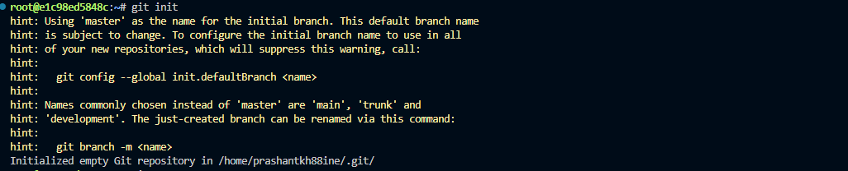

**3). Git status -**

* The git status command displays the state of the working directory and the staging area.
* Git status lets you see which changes have been staged, which haven't, and which files aren't being tracked by Git.

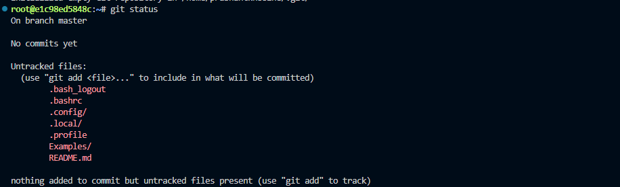

**4). Git add . -**

* The git adds command adds a change in the working directory to the staging area.
* Git add tells Git that you want to include updates to a particular file in the next commit.
* Git add doesn't really affect the repository in any significant way—changes are not actually recorded until you run git commit.
* The basic way to write the git add command is – a) git add . (where . signifies changes in the multiple files done) b) git add <filename> (If you want to git add a particular file )

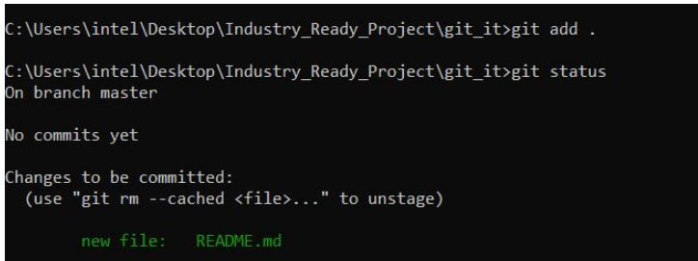

**5).git branch -**

* A branch in Git is simply a lightweight movable pointer to one of these commits.
* The Git branch can give you the list of branches that exists and in which branch you are currently working.

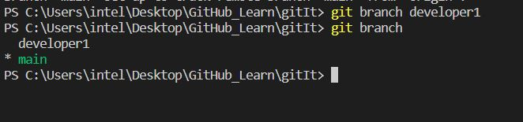

**6). git checkout-**

* The git checkout command lets you navigate between the branches created by the git branch .
* Checking out a branch updates the files in the working directory to match the version stored in that branch, and it tells Git to record all new commits on that branch.

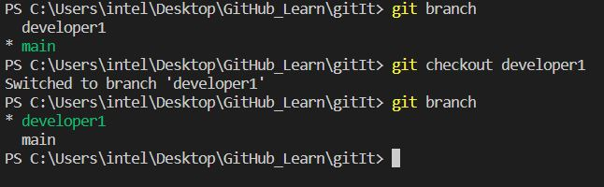

**7).git add images <link>-**

* This command will add an image from a link.

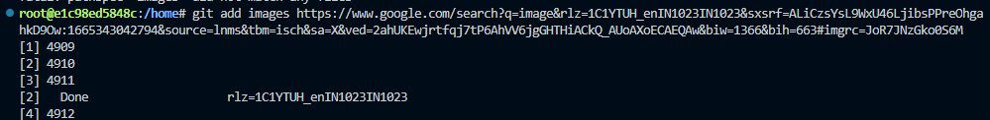

**8).git pull <link> -**

This command will pull the Remote Repository from the git hub to the working directory.

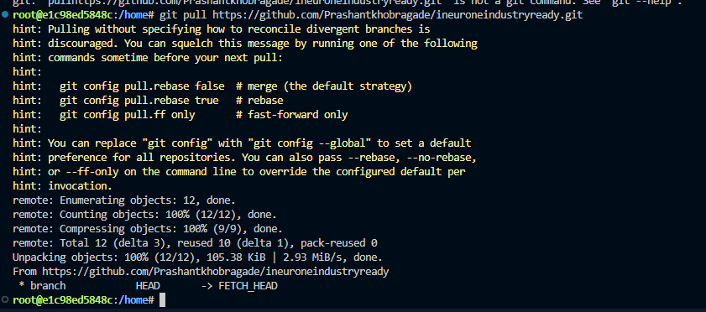

**9). git merge -**

This command merges the specified branch’s history into the current branch.

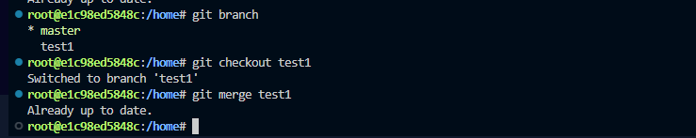

**10).git remote add -**

This command is used to connect your local repository to the remote server.



**11). Git push <file name> master -**

This command sends the committed changes of the master branch to your remote repository.

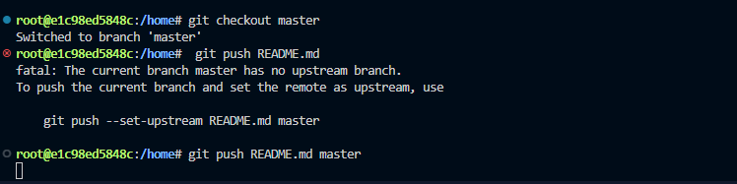

**12).git rm -**

This command deletes the file from your working directory and stages the deletion.

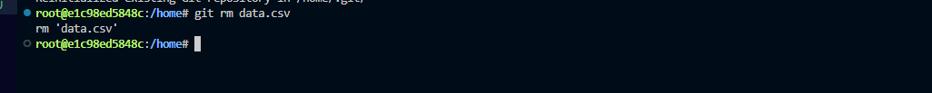

**13). Git log -**

This command is used to list the version history for the current branch.

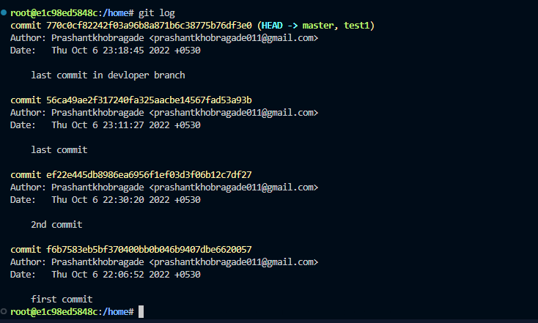

**14).git show -**

* Git show is a command line utility that is used to view expanded details on Git objects such as blobs, trees, tags, and commits.
* Git show command is similar to git log in terms of output. Git show also presents you the output in the same format as we studied in the git log tutorial. A slight difference is that the git show command shows you two things: The commit to which HEAD is pointing.

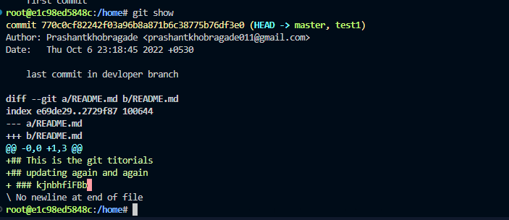

**15).git clone -**

To create a local working copy of an existing remote repository, use *git clone* to copy and download the repository to a computer. Cloning is the equivalent of *git init* when working with a remote repository. Git will create a directory locally with all files and repository history.

